**Website**

**Pages**

<https://michaelhyatt.com/>

**Who We Are**

***Note****: Click on The bar has* ***Who We Are*** *and it opens a page as that below (****1 page****)*

**Who We Are**

Living an Effective Lifestyle Inc. is one of Canadian leading Life Coaching Firm for living the effective life, dedicated to helping Canadians live an effectively.

Our intention is to help as many individuals and professional gain more clarity, understand their relevance and gain clear direction for their lives. A service we have been delivering through our Coaching, Mentoring, Seminars, Materials & Training

As seasoned Life Coaches and Train the Coach Trainers firm, we have counseled, consulted, and coached hundreds of individuals on their journey of discovering their life’s vision, relevance and purpose thus they could truly live the Effectively Lifestyle becoming the person they were destined to be, do and have.

**Our Belief/Philosophy**

Geese fly south because there's a south, individuals have an appetite for food because there's food. If there wasn't any south or food geese wouldn't fly there neither will an individual have an appetite.

We earnestly believe your life matters and means more than you've ascribed to it, You were crafted for an effective lifestyle and together we can help you make it count starting today.

**Our Approach**

Our proprietary coaching program, mentoring program, courses, workshops, books, and seminars provides simple yet practical tools and approach with the needed 1-on-1 support through the process.

Our approach to coaching is deeply rooted in our belief that every person on planet earth is born to accomplish something significant and to make a difference in their contributions to the society.

However, for any individual or organization to experience the reason for being and attend their fullest productivity they will have to understand who they are as a person or organization, How they are wired and what specific assignment they are here to solve (what problems you are designed to solve)

As your coaching partners we are positioned to help each person firstly, **ESTABLISH** who they are, secondly to **UNDERSTAND** their uniqueness and how they are wired, thirdly, is to **DISCOVER** their God-given purpose, life's vision or assignment. With these the three legs that hold up the stool, they can be **CLEAR** about the future they desire to accomplish, **CRAFT** a well-defined plan of action, and **IMPLEMENT** the plan with pinpoint accuracy, support, and partnerships.

Then can they truly live intentionally, move forward with great momentum, clarity, and vision; be happier, more productive and live a truly fulfilling life.

... Something we call "**Living the Effective Lifestyle**"

**Today’s**

**WORDs**

**in**

**SEASON**

***Note****: Click on The bar has* ***Today’s WORDs in SEASON*** *and it opens a page as that below (****1 page****)*

**Today’s WORDs in SEASON**

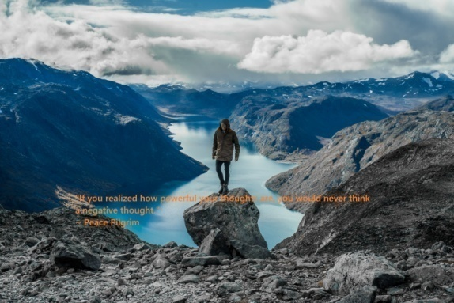 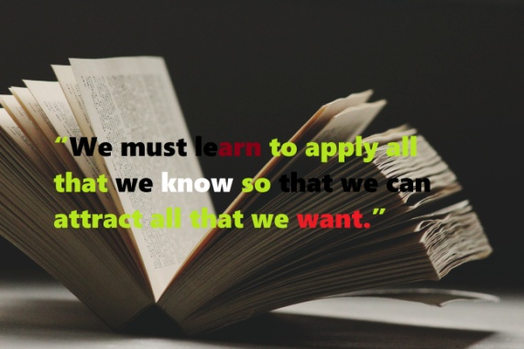

Same concept

<https://michaelhyatt.com/shareable-images/>

**Our Signature Training and Workshops**

***Note****: The bar has Our Signature Training and Workshops, when you put the console there it gives you a drop box with the options:*

*Unlocking Your Confidence & Inner Strength Signature Program™*

*Goal Setting Signature Program™*

*Becoming a Competent Reaper Signature Program™*

*Emotional Insight Signature Program™*

*Take Charge: ADVANCE Signature Program™*

*Click on any of the above and it open a page as that below (****5 pages****)*

**Unlocking Your Confidence & Inner Strength Signature Program™**

A healthy self-esteem is essential for growth and achieving success. Of all the

judgments an individual make in life, none is as important as the one they make about themselves. Without some measure of self-worth, life can be painful and unrelenting.

**Benefits of Attending**

◊ Recognize that you have worth and are worthy of happiness

◊ Develop techniques for eliminating unhealthy thought patterns and replacing them with supportive patterns

◊ Learn how to turn negative thoughts into positive thoughts

◊ Learn how to make requests so that you get what you want

◊ Set goals that reflect your dreams and desires and reinforce healthy patterns

**Goal Setting Signature Program™**

As Patch Adams rightly said... You've got to know what you want. This is central to acting on your intentions. When you know what you want, you realize that all that is left then is time management. You'll manage your time to achieve your goals because you clearly know what you're trying to achieve in your life.

At the end of each year, if you’re like most individuals and organizations, you are already making resolutions or setting some form of goals. But, sadly, most of them never realize those goals. It appears that setting goals are easy, but it’s just as easy to get discouraged, distracted, and derailed.

Huge percentages of individuals and organizations lose motivation and lose momentum. It does not have to be that way.

Through understanding simple yet intentional Goal-Setting & Planning procedures for effective results, you too can move forward with great momentum, clarity, and vision.

**Benefits of Attending**

● Recognize How Your Thoughts always Programs Your Outcomes

● Understand How Your Belief Is The Key That Unlocks Impossibilities.

● Discover The 3 Keys To Living An Effective Lifestyle and How Your Uniqueness Makes You Special

● Understand The Attachments You Need To Be Aware Of, So You Can Take Back Power From Your Excuses.

● Understand The 8 Aspect Of Your Life That Matters The Most.

● Understand How to Create Clear and Written Goals for the coming year and beyond, with Tangible Plans for Accomplishing them

● Discover simple yet practical tools, techniques to and the support to make 2018 your greatest year ever.

● Know the secret of creating a life of happiness and how you can tap into it by setting meaningful goals

● Why you can’t afford to live without clearly defined goals and the hidden cost of acting without direction, including discontent, frustration, and other negative emotions

● The importance of getting outside of your comfort zone and why this is your year to do it

**Becoming a Competent Reaper Signature Program™**

Becoming a Competent Reaper is a practical seminar for understanding how to REAP and become good at Reaping.

Many believers are of the mindset that reaping is automatic, just sow and you will reap, however, now farmer just sows and then goes out to reap because there are certain preparations that he or she must put in place to guarantee a harvest.

Have you ever wondered where is the 30/60/100 fold harvest you were promised in the word???

WELL, you are not alone. A lot of Christians are very good givers but lousy reapers. The misconception of the law of sowing and reaping has led to misunderstanding among Christians of the respective roles and relations displayed in sowing and reaping.

Folks are not reaping off what they sow and not harvesting the way they ought to.

**Benefits of Attending**

• Discover the key principle of sowing & reaping - As long as the Earth Remains

• Understand how reaping is strictly at God’s Direction

• Settle the concept of tithing and if it has changed?

• Understand all about gathering Faith

• Recognizing the time to Reap

• Knowing the key to Reaping in Joy

• Become a Wise Reaper

• Recognize and discover Why the Hold-up

• Understand the Accurate Allocation of earth’ Resources

• The importance of how to Obtain the Promise

**Emotional Insight Signature Program™**

Emotional insight, also called EQ or emotional intelligence, is the ability to be aware of and to manage emotions and relationships. It’s a pivotal factor in personal and professional success. IQ will get you in the door, but it is your EQ, your ability to connect with others and manage the emotions of yourself and others, that will determine how successful you are in life.

We have all worked with and listened to brilliant people. Some of them were great and… well, some were not so great. The mean and the meek and all those in between can teach us more than they realize. When we look at the truly extraordinary people who inspire and make a difference you will see that they do this by connecting with people at a personal and emotional level. What differentiated them was not their IQ but their EQ – their emotional intelligence. This one-day course will give you the EQ edge.

**Benefits of Attending**

• Understand what emotional insight, EQ or emotional intelligence really means

• Recognize how our emotional health and physical health are related

• Learn techniques to understand, use, and appreciate the role of emotional intelligence in the workplace

• Understand the different emotions and how to manage them.

• Create a personal vision statement.

• Understand the difference between optimism and pessimism

• Understand The seven human emotions and how to Validate emotions in others

• Discover your Personal life’s vision

• Understand your personal Values, principles, strengths, and talents

**Take Charge: ADVANCE Signature Program™**

Why are there so many different organizational systems and time management methods out there? The answer is simple: it’s like any other personal challenge, like weight loss or money management. There is no simple, one size fits all answer. You must build a solution that works for you.

Over the course of this workshop, we will explore various time management and organizational tools and techniques so that you can build a customized productivity plan for your personal lives. At the end of the course, you will emerge with a plan that works for you, so that you can start regaining control of your life!

**Benefits of Attending**

During this workshop, you will:

▢ Understand What personal efficiency is,

▢ Understand what skill sets can improve personal productivity, and what attitudes they should cultivate

▢ Discover What role long-term goals play in short-term efficiency

▢ How to set a personal vision and develop dreams and goals from it

▢ Understand The 80/20 rule and how it should affect planning

▢ Discover Ways of saying No!

▢ Discover How simple routines can simplify their lives

▢ Identify why they procrastinate and methods for tackling tasks

▢ Discover Tools to make their household more productive and efficient

▢ Understand how to Create a personal action plan

Please note that you will have to inquire which of the program is currently scheduled to enable you to enroll before enrollment close. To be notified when the next group becomes open, please click the link below.

**Coaching**

***Note****: The bar has Coaching, when you put the console there it gives you a drop box with the options:*

*What Is Coaching?*

*What Makes Us A Great Coaching Firm?*

*Click on any of the above and it pen a page as that below (****2 pages****)*

**What Is Coaching?**

Coaching is ACTION Oriented and it is all about Moving Forward, Not dwelling on the past. So with a coach it really doesn’t matter how you got to where you are now, who is to blame for how they turned out – Coaching is about where the person is right now and where he or she would like to be.

Coaching is helping the individual or group build that bridge from where they are right now and where they would like to be

Coaching is an ongoing partnership between the Coach and the client designed to improve and enhance the person that is been coached quality of life.

Coaching works because of the partnership that is created. The coach helps the client develop new skills and awareness.

Coaching helps the client overcome limiting believes that holds the client back from achieving their goals to having them more fulfilling, successful and effective lives.

Coaching can be defined as: “Supporting an individual or group of people through a TRANSITION in their lives”, especially in a season like this where most people are right now is in the middle of a lot of transitions in their lives. Transition is their career, work, businesses, spiritual life, financial, health, relationships, families, community...etc

**Why Coaching?**

In today’s world Coaching isn't just for sports anymore, however, the roots of coaching can be found in performances, successes, and Achievements of some sort.

Today coaches are helping people take the next steps in their lives, helping them successfully navigate through their transitions. Or it could be moving up to the next level of their health, relationship, work and financial lives.

With coaching, It becomes a lot faster and easier way to get to where you want to go to in your life if you have someone who cares, who is a professional supportive partner helping you in the process.

**What Is Life Coaching?**

Life Coaching is a professional service providing clients with Feedback, Insights, and Guidance from an outside vantage point.

The profession of coaching is similar to the practice of a physician, a trainer or psychologist, however, the major difference is that coaching is an On-going, Collaborative Partnership built on “Taking Action”

For example, say you want to accomplish a goal, maybe lose some few pounds or venture into a new career, or launch a new business, or get promoted at work or whatever it is you are looking to accomplish, you can either do it yourself or you can work with a supportive professional who will collaborate with you on the best ways to achieve your goals.

A coach will invest the needful time, attention and focus just to make sure you are not just prepared emotionally, physically and mentally to do what you need to do, but above all will hold you accountable to make sure you stick to your chosen programs each week and month until you accomplish your goal.

Something to also take to heart is that a coach who will help you decide what you really want for your life, getting clarity and purpose who will help you set goals tailored to your person, give you the required tools and support you all the way.

**Where Did The Concept Of Coaching Originate?**

According to history there has always been one sort of coach or another in the society – the town priest, the elders, the grandparents, uncle, aunty,

2014 Global Coaching Client Study showed that of those who had received coaching

80% saw improved Self-Confidence

73% saw improved Relationships

72% saw improved Communication Skills

70% saw improved work performance

61% saw improved business management

57% saw improved time management

51% saw improved team performance

99% indicated they were somewhat fully satisfied with their coaching experience.

96% said they would do it again

An article in the Washington Post June 2003 stated that people are now skipping the shrink and hiring a life coach instead. It is estimated that 80% of those seeing a therapist does not elicit a mental disorder.

Coaching appeals to people because it facilitates a confidential relationship with a trusted professional without any of the social stigma attached to it.

Life coaches are more than friends with whom to share your problems

Life coaches are sounding board for solutions to the challenges that we face on a daily basis.

Life coaches are mentors, in some cases, cheerleaders in others.

Life coaches are part consultant, part family.

Coaches unleash the power of partnership.

**What Is The Distinction About Coaching?**

Finally, it is very important I draw the distinction between coaching that also set me apart from all the rest.

Let us for a moment discuss the difference between being your Coach vs. Being a Therapist, vs. Being a Friend that gives good advice vs. being Supportive Spouse, vs. being a Consultant.

**Being your Coach vs. Therapist/Psychiatrist:**

- Both relationships develop over time.

- Confidentiality is critical in both.

- The needs and wants of the clients are the focus for both.

- There are professional ethics and standards for both.

**What are the Distinctions between Being your Coach vs. Therapist/Psychiatrist?**

Coaching clients are individuals who take responsibility and they will benefit from accountability. Therapist and Psychiatrist work with clients who need professional help to work towards healing, recovery and issue resolution.

Coaches will work with clients who want a detached partner to help them evolve and enhance their lives.

Therapists are experts in medical and behavioral sciences, and they are trained to treat diagnosable conditions like:

Post Traumatic Stress Disorder, Addiction, Depression, Bipolar Disorder & Other like conditions. While Coaches use personal disclosure as a tool to help and challenge their clients.

**Being your Coach vs. A Friend That Gives Good Advice:**

A coach holds the client accountable for what they want to create and achieve in their lives. Holding a friend accountable for what they want to create and achieve in their lives can bring trouble.

**What Are The Distinctions Between Being your Coach vs. A Friend That Gives Good Advice?**

Coaching is NOT advice-giving, we don’t give advice whereas friends do.

Being your Coach vs. being a Supportive Spouse:

It is difficult to stay objective because we are emotionally involved to our spouses.

**Being your Coach vs. Being A Consultant:**

Our Coaches come from a wide variety of backgrounds including:

Corporate, Education, Consulting, Communication, Law, Health Care and many others, and the truth are that there are as many types of coaches as there are people.

**What are the Distinctions between Being your Coach vs. Being A Consultant?**

As coaches we do not give advice, but rather guide the clients to their own solutions by asking powerful questions so that the clients allow their own inner wisdom to come to the right solutions for them. We are hired to support their clients as they achieve certain outcomes.

Consultants typically advise their client about how to solve problems.

They say this is what you do and this is how you do it, and this is the next step to take.

Consultants are focused on results and what they can measure. They are usually hired to produce a certain outcome.

**What Makes Us A Great Coaching Firm?**

● Each of our coaches has a strong commitment to their own personal awareness and growth, willing to evolve and develop themselves

● They each have a huge love for and desire to help people, genuinely curious about people, with a healthy sense of humor and humility.

● They each have great listening skills (both the unspoken and the spoken), listening at the deepest levels; know how to filter out their own emotions, judgment, and conclusions

● With a strong blend of loving-kindness and the ability to compassionately “Call clients on their stuff”

● Our Coaches have the gift and ability to recognize and articulating client’s strength.

● They each have a large capacity for non-judgment, they are open to outcomes but not attached to outcomes, they're able to make themselves blank for the client’s agenda so that solutions emerge.

● Our coaches have a positive orientation to life, and above all empathy, making the process All about the client.

**Our Coaching Signature Programs**

***Note****: The bar has Our Coaching Signature Programs, when you put the console there it gives you a* ***drop box*** *with the options:*

*Personal Coaching Signature Program™*

*The Effective Lifestyle Group Coaching Program™*

*Coaching the Coaches Signature Program™*

*Click on any of the above and it open a page as that below (****3 Pages****)*

**Personal Coaching Signature Program™**

All about helping people produce results. We want to understand you, your needs; and the results that you would want to accomplish.

Helping them find something from within – sometimes it is sharing ideas with them and helping them solve problems from within.

Our 5-Key Approach As Your Personal Coach

Our simple approach is to: Clarify. Strategize. Upgrade. Optimize. & Master…

It’s All about your Goals, your challenges, and your Progress

Let us facilitate your transition and help you get from where you are now to that result you desire.

Here’s the Overview of The Program’s Format:

☑ Weekly One On One Coaching Call With Coach Aniekan

☑ Coach/ Client Accountability Session

☑ Assignments, Worksheets, And Home Study References

☑ Fieldworks Relating To Each Week’s Focus Area

☑ Helping You Set New Levels Of Accomplishments For The Coming Week

What You Should Look Forward To:

◼ You will discover how to define your dreams and set up steps to move you in the direction of your dream.

◼ You will discover and recognize what exactly has been holding you back from accomplishing more than you have to date.

◼ You will understand how to be intentional knowing exactly what you want to do, have, become will move you forward with great momentum, clarity, and vision.

◼ You will own your coaching sessions and understand how to determine the Agenda for each session with your coach.

◼ You will experience the support and assistance in setting personal, meaningful goals, be in charge of the Planning and Strategizing.

**The Effective Lifestyle Group Coaching Program™**

The EL group-coaching is a 16-week program specially designed for persons desiring a sustainable and transformative change. You will be participating in a well-guided system built around foundational philosophy and belief: Clarify. Strategize. Upgrade. Optimize. & Mastery

The size of the group usually ranges from 10 to a maximum of 12 individuals, therefore, allowing a very close and neatly developed intimacy not just with each member of the group but also with your coach.

**Here’s the Overview of The Program’s Format:**

☑ Weekly Group Video Conference

☑ Coach/ Group Accountability

☑ Assignments, Worksheets, and home study references

☑ Access to video sessions related to each week’s focus area

☑ One on One Coaching Call with Coach Aniekan

**What You Should Look Forward To:**

**▢** You will understand how to be intentional knowing exactly what you want to do, have, become and also how to set and write your own goals

**▢** You will get to identify yourself in a deeper but also personal dimension to enable you to plug in wholeheartedly

**▢** You will get to meet other people who are also on their own coaching journey and you get to also expand your network.

**▢** You will understand how to rely on group members to support you through your process, which will not only build your confidence but also motivate and challenge you to reach higher heights

**▢** You will discover a clear understanding how you can align goals with your life's vision and purpose, using simple yet proven strategies for achieving any goal.

**▢** You will discover how to harness the emotional power of your goals to cultivate confidence and a sense of accomplishment and also help other members develop confidence with a sense of accomplishment.

Please note that you will have to inquire Effective Lifestyle Group Coaching Program is currently scheduled to enable you to enroll before enrollment closes.

However, to be notified when the next group becomes open, please click the link below.

**Coaching the Coaches Signature Program™**

**For people who desire to start a coaching business or who are already running a coaching business and would want to grow their business.**

The rise of a fast growing business industry – coaching. People around the world are using their natural desires to contribute and support others as the foundation of launching and building a successful business online and building a lifestyle that really works for them.

I believe you either know someone who is a coach, or you have used a coach or have heard someone talking about their coach or you may even be a coach yourself… the questions I want to ask are these:

**Here’s the Overview of The Program’s Format:**

**⌂** 8 hours intensive Workshop

**⌂** Coach/ Group Accountability

**⌂** Assignments, Worksheets, and home study references

**⌂** Coach/ Coach Accountability Session

**⌂** Helping You Set Up Your Coaching Business

**What You Should Look Forward To:**

**⌂** You will discover what type of coaching style and offer you possess

**⌂** You will discover if you have what it takes to run a coaching business

**⌂** You will discover what coaching really is and why coaches becoming so successful.

**⌂** You will understand what coaches really do and don’t do.

**⌂** You will understand how to consistently deliver the effective lifestyle coaching results

**⌂** You will understand the legal and financial aspects of your coaching business.

**Contact Us**

***Note****: The bar has* ***Contact Us****, Click on it and it open a page as that below*

**Contact Us**

**Living an Effective Lifestyle Inc.**

Suite 1457,

1011 Upper Middle Road East,

Oakville, Ontario

L6H 5Z9,

Canada

Telephone: +1 905 379 2427

Email: info@livinganeffectivelifestyle.com

Website: http//www. livinganeffectivelifestyle.com

**Free Resources**

***Note****: The bar has Free Resources, Click on it and it open a page as that below*

**Free Resources**

MailChimp

Nothing is more important than building your own e-mail list. I use MailChimp to manage mine. It has a super easy-to-use interface, great analytics, and is 100 percent reliable. Other people prefer AWeber. I don’t think you can go wrong with either one.

https://mailchimp.com/monkey-rewards/?utm_source=freemium_newsletter&utm_medium=email&utm_campaign=monkey_rewards&aid=52d5c7778a3adfda535c3b349&afl=1

GOOGLE ANALYTICS

GOOGLE

This is the gold standard when it comes to analytics. If you want to track your unique visitors, page views, bounce rate, and a host of other metrics, you need to sign up for a free account and then follow the directions for installing it on your blog. I wish I had set this up from the day I started blogging. It is invaluable.

LEARN MORE

http://www.google.com/analytics/#?modal_active=none

AKISMET

AUTOMATTIC

This is the plugin I use to control comment spam. Even though I receive more than 500 comments a day, I get very little spam. Akismet blocks almost all it, so it never sees the light of day. This creates less work for you and less friction for your readers. (For example, you don’t have to require them to register to leave a comment.)

LEARN MORE

https://akismet.com/

BLUEHOST

If you use WordPress as I recommend, you will need a hosting service too. I recommend BlueHost. They are currently offering a special $3.95 a month rate to my readers. I also have a free screencast that will show you how to set up a WordPress site on BlueHost in 20 minutes or less.

LEARN MORE

https://www.bluehost.com/special/michaelhyatt?utm_source=%28direct%29&utm_medium=affiliate&utm_campaign=affiliate-link_michaelhyatt_Blogger

With logosquarespace, you can easily your company logo.

They say it is Logos made simple, and by just entering your company's name you can get started

https://logo.squarespace.com

Free Logo Maker

Create your logo for free online. It’s a super simple solution for business owners, startups, online companies, and beyond. Once you’re ready, just pay $19.99 to download the files.

https://www.graphicsprings.com

**Connect & Work With Us**

***Note****: The bar* ***Connect & Work With Us****, Click on it and it open a page as that below*

**Connect & Work With Us**

Living an Effective Lifestyle Inc. we have discovered how to help individuals and professionals in the small, medium and large organization understand effectiveness in regards to their lives and how they function individually or within a group to improve productivity and sales within an organization from the least to the top personnel.

Our proprietary coaching program that has helped countless individuals like yourself discover their life’s vision, passion, key potentials to living a more effective lifestyle, so they can be happier, be more productive and have a fulfilling life. Providing simple practical tools, the support and as well hold you by the hands to walk you through the process with our Life Coaching Signature Program™.

In most of our trainings, public speaking and seminars we are often asked what our suggestions would be in getting started; one major area we have always suggested is firstly “getting a coach” especially if this is something you’ve struggled with for a while or something you have tried doing with little or no success or even something you have always wanted to do but never had the courage to go for it.

A life coach, for instance, will offer you a professional service where you will be getting Feedback, Insights, and Guidance from an outside vantage point.

The profession of coaching is similar to the practice of a physician, a trainer or psychologist, however, the major difference is that coaching is an On-going, Collaborative Partnership built on “Taking Action”

Let your life coach help you define your dreams, help you recognize what is holding you back, and also help you move forward with great momentum, clarity, and vision.

For more information on how you can discover your key potentials to living a more effective lifestyle, be happier, be more productive and have a fulfilling life simply request our free consultation session or for more information email info@livinganeffectivelifestyle.com, you’ll be glad you did.

**Our Team**

***Note****: The bar* ***Our Team****, Click on it and it open the team page.*

*What it will have are pictures of each member with their name & designation.*

***Our Team History***

*Coach Aniekan Joshua Whyte*

*Life Coach, Author & Professional Speaker*

*Diana O. Whyte (Mrs.)*

*Facilitator, Curriculum Developer, International Speaker*

*Coach Doug A. Schneider*

*Coach, International Speaker, & Author*

*Austin J. Otah, Esq, Notary, MA*

*International Legal Practitioner, Author & Speaker*

*Abi Olusoji*

*Trainer, Speaker & Author*

*Victor Umezuruike*

*Web Designer, Developer & Content Management Expert*

**Our Team History**

**Our Leadership**

Our leadership team is responsible for the mission, vision and direction of the business... They diligently plan our every aspect of the business and , and the accomplishment of final goals.

They lead gracefully and tirelessly into new frontiers with a heart for customer satisfaction and fulfillment, while watching diligently for the welfare of the team. They believe as one of their mentors Zig Ziglar rightly said that… We build a better company by building better people -

Their love for people and a heart for the reliability of our services, message and products reflect strongly in everything we do as a company.

**Our Trainers**

Our Trainers have garnered over 22 years learning the act of creating WOW moments in our training and workshops, by utilizing role plays, group discussions, case studies and videos to make learning fun and unforgettable

They use a blended learning approach to all our learning programs and participant interaction are key part of our training sessions. This format has proved to be a powerful way to help participants understand complex ideas and, most importantly, develop a common understanding and approach to using theories and applying tools to make a real difference in the performance of their responsibilities.

**Our Legal & Finance**

Dually qualified legal practitioner and international based legal consultancy. Associate of the Chartered Institute of Arbitrators, Member of the Nigerian Bar Association, International Bar Association and the Law Society UK

While our financial team are obsession with detail, been able to always protect the welfare of our company with unceasing dedication, while adding value in many ways.

Saddled not just with the responsibility for our income, and expenses, they also see to the balance of personnel... The great thing is that he does it with such passion, effectiveness and excellence.

**Coach Aniekan Joshua Whyte**

*Life Coach, Author & Professional Speaker*

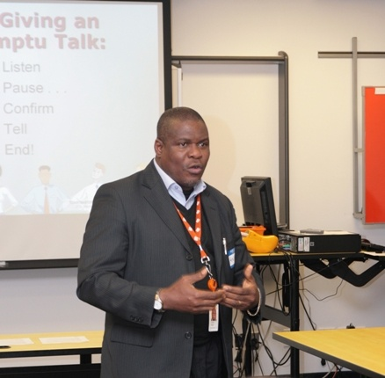 Aniekan for the past 20 years has been helping countless individuals and business professionals build that bridge from where they are now to where they would like to be. This on-going partnership is designed to improve and enhance the quality of lives with extensive coaching practices in North America, Europe, the Caribbean and West Africa.

**Diana O. Whyte (Mrs.)**

*Facilitator, Curriculum Developer, International Speaker*

 Diana is a dedicated training professional, leading a dedicated training team. She is an accomplished speaker, trainer, facilitator and program evaluator with a primary focus on self-actualization, as well as transformational and progressive leadership. Diana has garnered her expertise from over twenty-two years of working experience in large organizations and corporations in Canada and the Caribbean Islands. Her workshops and facilitation have helped leaders in various capacities worldwide. She has published several articles on private life upliftment creating wow customer service, effective communication, and leadership skills. She has served as keynote speaker at international conferences focusing on developing high-performance teams and delivering excellent services in high-stress environments. She has also served as a guest lecturer to schools in the Caribbean Islands and Canada. Her areas of expertise include Customer Relationship Management, Training Design, Delivery, and Facilitation; Performance Consulting; Program Design and Evaluation and Needs Assessment.

**Coach Doug A. Schneider**

*Coach, International Speaker, & Author*

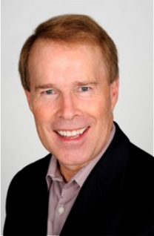Dr. Doug A. Schneider has traveled to over 40 countries of the world and addressed over 3,000 different audiences. He comes with a message of hope, encouragement, and vision. Doug believes that people respond best when they’re positively inspired, given suitable training and offered opportunities to participate with others. Inside of all of us is a unique DNA seed of skills and ability. It’s really not that difficult to turn the ordinary into extraordinary when your life becomes “unlocked”.

**Austin J. Otah, Esq, Notary, MA**

*International Legal Practitioner, Author & Speaker*

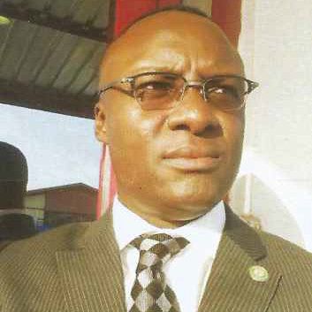 Austin is the CEO of Legum Consult, a legislative and public affairs company founded by reputable and experienced former Legislators, Advocates and Academics in the field of Law and allied areas with over 100 years combined experience, both locally and internationally. Austin was enrolled as a Solicitor of the Supreme Court of England and Wales in 1999.

**Abi Olusoji**

*Trainer, Speaker & Author*

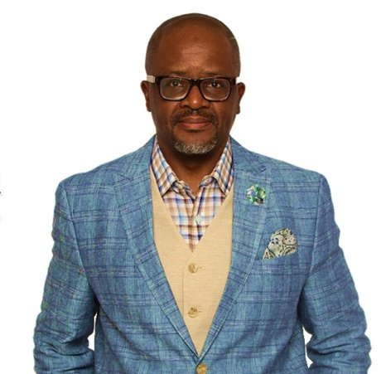 Abi Olusoji is a resourceful and impactful trainer and speaker who has been exploring the principles of personal effectiveness and successful living for about two decades now.

A strong investor in human potential development, Abi’s calling and passion is to see people discover their potential deposits and maximize their allocation of time resource for the benefit of humanity.

**Victor Umezuruike**

*Web Designer, Developer & Content Management Expert*

 Victor is a seasoned web developer, with vast experience in PHP, bootstrap and content management systems. Having developed several websites over the years, he has developed a work approach for himself, which is what he fondly calls "work hard, but smartly".

**Join Our Team**

Are you interested in joining our team? Working with us will enable you can tunnel into your desired area of expertise and grow as an individual, a team player and also professionally. Visit our careers page to find out what positions are currently available